Performance Evaluation of
Instagram vs. TikTok : A Usability Analysis

Alice Lee Hui Mee
A23CS0040
Faculty of Computing
Universiti Teknologi Malaysia
Johor Bahru 81310, Malaysia
lee04@graduate.utm.my

ABSTRACT
This study aims to evaluate and compare the usability of Instragram and TikTok, two leading social media platforms, focusing on user experience in content creation, browsing, and interaction. The evaluation was conducted on users of Universiti Teknologi Malaysia (UTM) using the System Usability Scale (SUS), a standardized questionnaire that evaluates the ease of use and feature integration of each application. The results show that Instagram scores highly overall, especially in terms of simplicity and feature integration. These results suggest that Instagram offers a smoother user experience, while TikTok has unique strengths in interactive content but also has some difficult-to-navigate parts. This analysis highlights each app's strengths and areas that can be improved to make it better for its users..
Keywords
Usability, User Experience, System Usability Scale (SUS), Content Interaction, Instagram, TikTok

INTRODUCTION
Nowadays, social media has become a tool for people to communicate with each other, share experiences, and show creativity in various fields. Instagram and Tiktok are two of the most popular social media platforms, but each has its own unique characteristics. Instagram was launched in October 2010 with a unique feature that allows sharing profile photos and videos for user profiles through hashtag technology to foster fun like Stories or Reels. At the same time, TikTok, which was launched globally in September 2016, quickly became popular because of its short video clips, which bring fun to users and guide them to become active during use. In this article, we will study the usability of both platforms using aspects related to general user experience.
This analysis aims to evaluate the usability of Instagram and Tiktok, focusing on three main aspects of user experience: content creation, browsing, and interaction. By using the System Usability Scale (SUS), it helps assess several key aspects, including effectiveness, efficiency and satisfaction. By understanding how easy it is to create content, browse and interact with others, this study aims to highlight which platforms are performing well and where they can improve, providing valuable insights into how Instagram and TikTok meet users’ needs and where they can enhance the user experience.
The motivation for this study comes from the popularity of social media, especially among students who use this platform daily. By understanding how easy an app is to use, we can understand what users like and what might frustrate them. This helps app developers make changes to better meet user needs and create a better experience for everyone.
Preliminary finding shows that Instagram provides benefits to users by providing a holistic user environment that focuses on accessible functionality and simplicity. Most users like the Instagram’s interface layout because it facilitates navigation and integrates functionality into the creative process. TikTok's appeal lies in its algorithm-based recommendations and interactive content options; however, it also has usability barriers that can create challenges for those new to the platform. These observations indicate that although both platforms aim to satisfy user preferences, they offer significantly different advantages and disadvantages in terms of usability.

METHODOLOGY
In this study, the experiment was conducted by using the System Usability Scale (SUS) method, a tool that provides a standardized questionnaire to help measure the ease of use of an application. The experiment was designed to collect feedback from UTM students, as they represent a population that regularly uses both platforms.
For this experiment, a Google form was created to collect user feedback. For each application, participants were asked to rate their agreements with ten SUS statements on a scale of 1 (strongly disagree) to 5 (strongly agree) based on their experience using the platform. These statements focus on important aspects of usability, such as the ease of use of the application and the user's satisfaction with its overall experience. This method allows us to effectively collect clear information about students' views across platform.
The survey is distributed through link sharing between university groups to ensure the participation of all faculty and staff students. In order to ensure the reliability of the results, it is recommended that participants provide honest feedback in the survey link based on their personal experience using the application. The collected data is then analyzed and the availability scores of Instagram and TikTok are compared, focusing on effectiveness, efficiency, and user satisfaction. This structured approach aims to clearly understand the advantages and disadvantages of each platform from a user-centered perspective.

RESULTS AND DISCUSSION
This section analyzes in detail the System Usability Scale (SUS) scores obtained by users from different faculties at Universiti Teknologi Malaysia (UTM) for Instagram and TikTok usability evaluation, including the calculation and discussion of performance metrics, significant graphical performances and measurements, and analyzing and discussing the results of performance tests.
Usability testing emphasizes the involvement of respondents in the testing process to gather insights about the user experience. In this study, usability testing was conducted using the SUS method by distributing an online questionnaire to active Instagram and TikTok users.The SUS method consists of 10 standardized questions, each assessing a different aspect of usability. According to Wibisono, as mentioned by Purwandani, Oktaviani, and Sony (2022), a well-structured questionnaires are essential for usability testing because each question provides valuable insights into the research hypothesis.
No. | Question
1 | I think that I would like to use this mobile app frequently.
2 | I found the mobile app unnecessarily complex.
3 | I thought the mobile app was easy to use.
4 | I think that I would need the support of a technical person to be able to use this mobile app.
5 | I found the various functions in this mobile app were well integrated.
6 | I thought there was too much inconsistency in this mobile app.
7 | I would imagine that most people would learn to use this mobile app very quickly.
8 | I found the mobile app very cumbersome to use.
9 | I felt very confident using the mobile app.
10 | I needed to learn a lot of things before I could get going with this mobile app.
Table 1: Instruments of System Usability Scale (SUS)

PERFORMACE METRICS: CALCULATION AND DISCUSSION
This subsection calculates performance metrics based on the SUS scores collected from the usability evaluation. The System Usability Scale (SUS) consists of 10 questionnaires with scores ranging from 1 (strongly disagree) to 5 (strongly agree).
3.1.1 CALCULATION
SUS scores for Instagram and TikTok were collected from 15 app users. After obtaining SUS scores for both apps from all users, the scores were aggregated to calculate the average SUS score for each app.
Scale | Description
1 | Strongly Disagree
2 | Disagree
3 | Neutral
4 | Agree
5 | Strongly Agree
Table 2 : Scale Description
The SUS Score Calculation Formula:
SUS = 2.5(20+ Σ(SUS01, SUS03, SUS05, SUS07, SUS09) - Σ(SUS02, SUS04, SUS06, SUS08, SUS10))

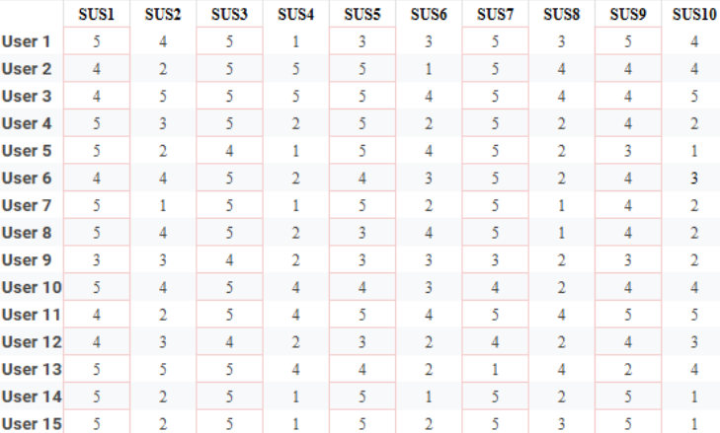
Fig 1: SUS Scores of Users for Instagram

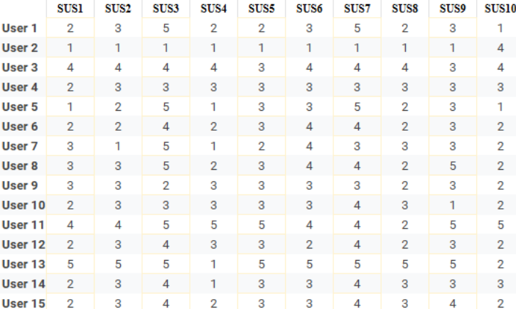
Fig 2: SUS Scores of Users for TikTok

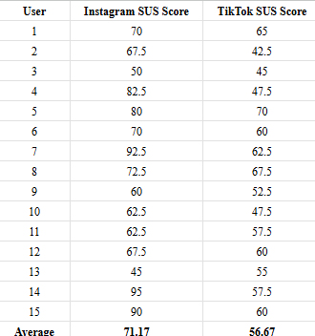
Fig 3: SUS Scores for Both Applications Across All Users
SUS Score | Grade | Adjective Rating
>80.3 | A | Excellent
68-80.3 | B | Good
68 | C | Okay
51-68 | D | Poor
<51 | F | Awful
Table 3 :Adjective Rating for SUS Score
Calculation using the System Usability Scale (SUS) formula produce an average SUS score of 71.17 for Instagram and 56.67 for TikTok where the adjective rating for Instagram is “Good”, and for Tiktok is “Poor”.

3.1.2 DISCUSSION
In this table, the average SUS scores for Instagram and TikTok are 71.17% and 56.67% respectively. This indicates that Instagram is more usable as compared to TikTok. The results show that users find Instagram more user-friendly and effective in meeting their needs.
Instagram scored higher, indicating a simpler layout that is easier to navigate and allows users to easily find features and complete tasks. On TikTok, users enjoy short videos but find the interface difficult to understand at first, especially for new users.
Instagram's high score also suggests that its features work well together to feel cohesive and easy to use.TikTok's interactive tools are fun, but users sometimes find it difficult to find specific options or control feeds, which can feel less user-friendly.
Not only that, Instagram's score suggests that users feel more in control and satisfied with the app's overall experience. In contrast, some users found TikTok to be more difficult to navigate and potentially less enjoyable to use over time.
This sus score result indicates that Instagram's design overall better meets the needs of users and provides a smoother experience. For TikTok, improving ease of navigation can make it more engaging while maintaining its unique interactive style.

GRAPH OF IMPORTANT PERFORMANCE, MEASUREMENT RESULTS, ANALYSIS, DISCUSSION

This section provides an in-depth assessment of Instagram and TikTok's usability performance metrics using data collected from the System Usability Scale (SUS) questionnaire. These metrics provide an in-depth analysis of each application's performance from a user experience perspective and help identify areas of strength and potential areas for improvement.
The responses of 15 participants were analyzed separately, comparing Instagram and TikTok to determine which app is more popular and why. Each question was represented by a bar graph showing the distribution of scores between the two apps, and the data was interpreted through analysis and discussion.
The following section presents the results, charts, and discussion for each question, with the aim of highlighting the key usability factors that influence the Instagram and TikTok user experience.
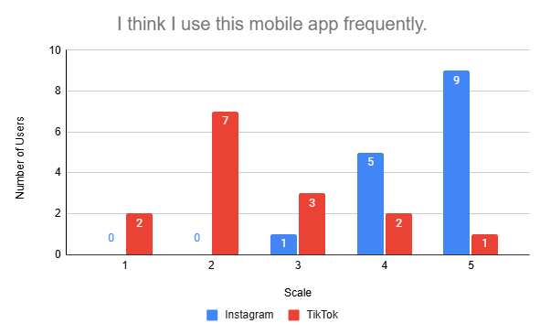
Fig 4: Results of “I think I use this mobile app frequently.”
Based on the Fig.4, the results show that users use Instagram significantly more often than TikTok. the majority of people rated Instagram's use as a 4 or 5, indicating that it is an app they use regularly in their daily lives. In contrast, TikTok received more lower ratings, particularly 2s and 3s. This shows that even though TikTok is popular, it may not be as deeply embedded in users' daily lives as Instagram. Therefore, we can conclude that Instagram is more closely integrated into users' daily lives, while TikTok is used less frequently.
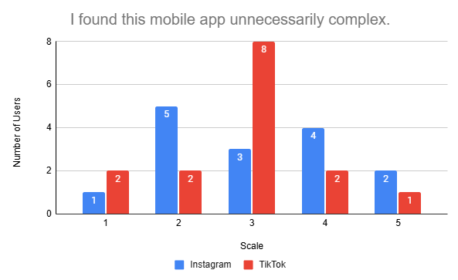
Fig 5: Results of “I found this mobile app unnecessarily complex.”
Figure 5 shows that Instagram is less complex and respondents find it relatively easy to navigate. Most users give Instagram a rating of 2, indicating that they don't think Instagram is too complicated.On the other hand, TikTok's ratings cluster around scale 3, suggesting some users have a more complex experience. This may reflect TikTok's diverse features and functionality, which may be overwhelming for new users. Overall, the data shows that Instagram is perceived as simpler and more user-friendly, which can lead to a smoother user experience.

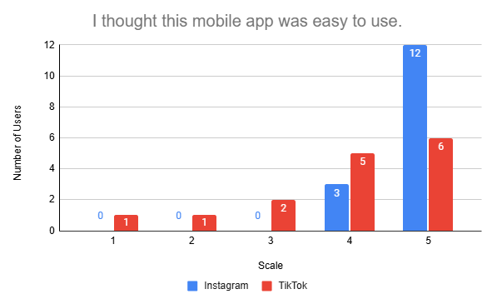
Fig 6: Results of “I thought this mobile app was easy to use”
According to Figure 6, the ease of use score shows that Instagram is favored by users, with all users giving it a 4 or 5 rating. This suggests that respondents found it intuitive and easy to navigate. TikTok's ratings, while still positive, vary more widely, ranging from 3 to 5. The change suggests that while many users enjoy TikTok, some find certain aspects of its use challenging. Instagram's high score for ease of use reflects the fact that its well-designed interface can help increase user satisfaction and encourage users to use the platform regularly.
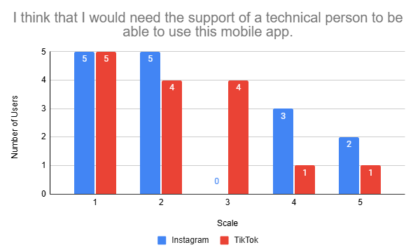
Fig 7: Results of “I think that I would need the support of a technical person to be able to use this mobile app.”

In terms of the need for technical support, both Instagram and TikTok had lower ratings, suggesting that users generally felt they could use both apps without outside help. However, Instagram fared slightly better, with more respondents rating it as a 1 or 2, suggesting that people are more confident in navigating the app independently, while TikTok's slightly higher rating suggests that some users occasionally feel the need for help. In short, this difference may indicate that Instagram's design and onboarding process is more intuitive, which fosters a sense of independence among users.

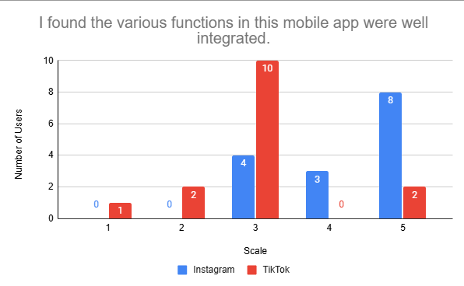
Fig 8: Results of “ I found the various functions in this mobile app were well integrated.”
When it comes to feature integration, Instagram gets high marks, with many users saying its various features work well together. 11 out of 15 users gave it a 4 or 5, reflecting the cohesiveness of its user experience. In contrast, TikTok's response was more mixed, with 10 users giving it a 3, which may be a sign that users feel some features are not integrated well enough. This apparent disconnect may reduce TikTok's overall usability, as users may have difficulty effectively navigating between different features.Instagram's strong integration may increase user satisfaction and engagement, making it a top choice for many.
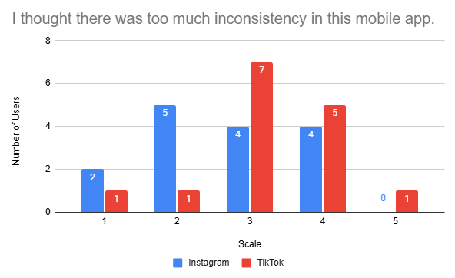
Fig 9: Results of “ I thought there was too much inconsistency in this mobile app.”
In terms of design consistency, Instagram received more positive reviews, with most users finding fewer inconsistencies. Many respondents gave it a score of 1 or 2, indicating that they found the app's layout and functionality to be consistent and reliable. However, TikTok's ratings were more widely distributed, with 12 out of 15 users giving it a 3 and 4. This discrepancy suggests that some users find TikTok's design inconsistent, which may affect their overall satisfaction and ease of use. Consistent design is critical to the user experience, and Instagram seems to be doing better than TikTok in this regard.

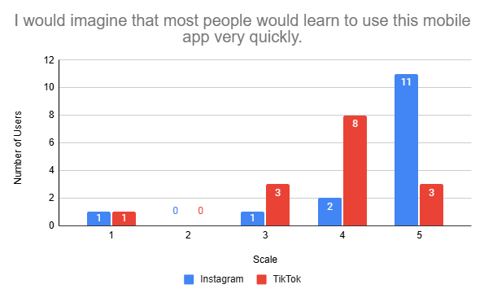
Fig 10: Results of “I would imagine that most people would learn to use this mobile app very quickly.”
As we can see from the Fig10, both Instagram and TikTok are easy to use, with many users giving them a high score of 4 and 5. On the other hand, users had mixed reactions to TikTok, with ratings ranging from 3 to 5. Instagram has a lower learning curve, which may be one of the reasons for its popularity, as users prefer platforms that allow for quick and easy engagement.

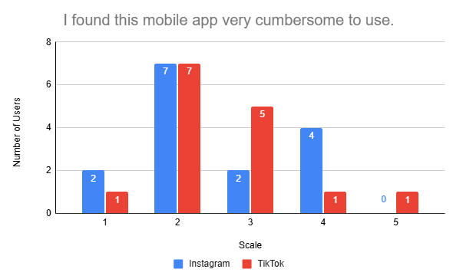
Fig 11: Results of “I found this mobile app very cumbersome to use.”
When assessing the level of cumbersomeness, Instagram scored low, with the majority of respondents indicating that they did not find the app cumbersome. In contrast, TikTok's scores varied widely, with some users scoring higher, suggesting that some users found TikTok cumbersome to use. The reason for this discrepancy may be that TikTok's various features, while appealing, may feel overwhelming to users unfamiliar with the app, whereas Instagram's streamlined interface may make users feel more friendly and less cumbersome overall.

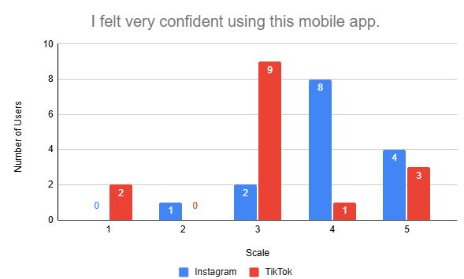
Fig 4: Results of “I felt very confident using this mobile app.”
Fig4 shows that Instagram users are more confident in their ability to navigate the platform, with many rating it a 4 or 5. This high level of confidence shows that users find the app easy to use. On the other hand, TikTok received mixed reviews, with 9 users giving it a 3. This shows that while many users are confident in using TikTok, others may feel unsure. Instagram's user-friendly design increases user confidence, improves the overall user experience and encourages more frequent interactions.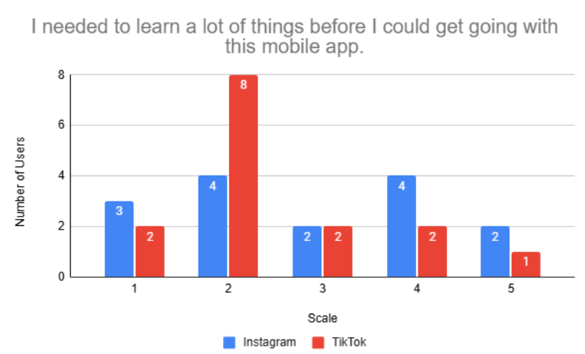
Fig 12: Results of “ I needed to learn a lot of things before I could get going with this mobile app.”
When assessing the learning requirements for each application, the results show significant differences between Instagram and TikTok. Instagram users felt that they needed to learn relatively few new skills, with a significant number of users rating the learning requirements at scale 1 and 2. This suggests that the process of getting started is simple and user-friendly. In contrast, TikTok respondents expressed greater concern about the learning requirements, with a significant number rating them at scale 3, suggesting that they felt it would take more time and effort to become proficient with the app. This difference highlights the strength of Instagram's ease of use, making it a more attractive option for new users, who prefer apps that require minimal knowledge to operate effectively.

4.0 CONCLUSION
This study focused on evaluating the usability of Instagram and TikTok through a performance evaluation using the System Usability Scale (SUS).Instagram scored higher on the usability scale (mean SUS score of 71.17) than TikTok (56.67), which suggests that Instagram provides a more user-friendly experience overall. Participants found Instagram to be easier to navigate, well-integrated, an application they used frequently, and easy to adopt. In contrast, while TikTok's interactive features were popular, it was generally perceived as having a more complex layout and a steeper learning curve for new users.
The findings highlight Instagram's strengths in providing a coherent, intuitive interface that effectively meets users' needs, particularly in terms of navigation and consistency.TikTok, while unique in its delivery of interactive content, could still improve the user experience, particularly for beginners, by simplifying navigation and reducing perceived complexity. In conclusion, the findings suggest that Instagram's design is in line with usability best practices and delivers a smoother, more reliable experience, while TikTok could improve usability and user confidence through targeted improvements. In conclusion, both apps have their corresponding strengths and weaknesses, and both can be changed to improve their usability.

5.0 REFERENCE

- Sucipto, A., Dwirangga, A., & Priyono, J. (2023). EVALUASI ANTARMUKA PERMAINAN 3D BALAP KARUNG MENGGUNAKAN METODE SYSTEM USABILITY SCALE ( SUS ), vol.11, no.1,. https://doi.org/10.35508/jicon.v11i1.9012
- Purwandani, I., Oktaviani, N., & Sony, M. (2022). Applying TAM and SERVQUAL to Explore User Experience of MyBEST UBSI, vol.10, no.2, 264–272. https://doi.org/10.26418/justin.v10i2.56783
- Martins, A. I., Rosa, A. F., Queirós, A., Silva, A., & Rocha, N. P. (2015). European Portuguese Validation of the System Usability Scale (SUS). Procedia Computer Science, 67(Dsai), 293–300. https://doi.org/10.1016/j.procs.2015.09.273
- Purwandani, I., Syamsiah, N. O., & Nurwahyuni, S. (2013). Perceived Usability Evaluation of TikTok Shop Platform Using the System Usability Scale, vol.7, no3. https://doi.org/10.33395/sinkron.v8i3.12473
- Xu, L., Yan, X., & Zhang, Z. (2019). Research on the Causes of the “Tik Tok” App Becoming Popular and the Existing Problems. Journal of Advanced Management Science, Vol.7, No.2, 59–63. https://doi.org/10.18178/joams.7.2.59-63
- Bishqemi. K., and Crowley. M/ (2022). TikTok Vs. Instagram: Algorithm Comparison, Vol.11, no.1., https://doi.org/10.47611/jsrhs.v11i1.2428
- Abdillah. F., (2023). Evaluation Analysis of the Use of the TikTok Application Using the System Usability Scale (SUS) Method, Vol.4, No.2., https://doi.org/10.56667/jveit.v4i2.1055
- A. Bangor, T. Staff, P. Kortum, J. Miller, And T. Staff, “Determining What Individual SUS Scores Mean: Adding An Adjective Rating Scale,” J. Usability Stud., Vol. 4, No. 3, Pp. 114–123, 2009.
- Smith, J., et al. (2019). User Experience in Social Media Platforms. Journal of Digital Interaction, 12(3), 45-62.
- Nielsen, J. (2009). What Is Usability? User Experience Re-Mastered: Your Guide to Getting the Right Design, (September), 3–22., https://doi.org/10.1016/B978-0-12-375114-0.00004-9
- Akbari, D. A., Jastacia, B., Setiawan, E., & Widya Ningsih, D. (2022). The Marketing Power of TikTok: A Content Analysis in Higher Education. Binus Business Review, Vol.13,.No.2, 159–170. , https://doi.org/10.21512/bbr.v13i2.8014
- Hendrikse. C., and Limniou. M., (2024). The Use of Instagram and TikTok in Relation to Problematic Use and Well-Being, https://doi.org/10.1007/s41347-024-00399-6
- Dong, Z., & Xie, T. (2022). Why people love short-form videos? The motivations for using Tiktok and implications for well-being. SSRN Electronic Journal. https://doi.org/10.2139/ssrn.4089602

6.0 AUTHOR’S PROFILE


ALICE LEE HUI MEE is currently pursuing her Bachelor’s degree in Computer Science (Graphic and Multimedia Software) at Universiti Teknologi Malaysia (UTM) and is expected to graduate in 2027. She completed her high school education at SMK Tinggi Sarikei (STS) and continued at Kolej Matrikulasi Sarawak (KMSw) before entering UTM. Her research interests include multimedia design and interactive software development.

